Name (netid): Sairamasubash Muppalaneni (smuppa3)
CS 441 - HW 3: Application Domains and Foundation Models

Complete the claimed points and sections below.

Total Points Claimed [112] / 142

- CLIP: Contrastive Language-Image Pretraining
  - Test CLIP zero-shot performance [0] / 10
  - Test CLIP linear probe performance [15] / 15
  - KNN on CLIP features [15] / 15
- Fine-tune Model for Pets Classification
  - Display Loaded ResNet-34 structure [5] / 5
  - Epochs vs Loss Plots [15] / 15
  - Best Performance [10] / 10
- Applications of AI
  - Describe the applications [15] / 15
  - Positive impact [5] / 5
  - Negative impact [10] / 10
- Stretch Goals
  - Compare word tokenizers [20] / 20
  - Implement/train custom network [0] / 20
  - Completed HW2 survey by Mar 9 [2] / 2

1. CLIP: Contrastive Language-Image Pretraining

- CLIP zero-shot performance

  - Your test accuracy:

- CLIP linear probe performance

  - Your test accuracy: 0.9362745098039216 => 93.627%

- KNN on CLIP feature

  - Your test accuracy: 0.85 => 85%

  - Best K: 11

2. CNN: Image Classification
- Network Structure and number of parameters:
Here are the images of the network structure and number of parameters after replacing the last layer so that the output deminsion matchs the number of pet classes:
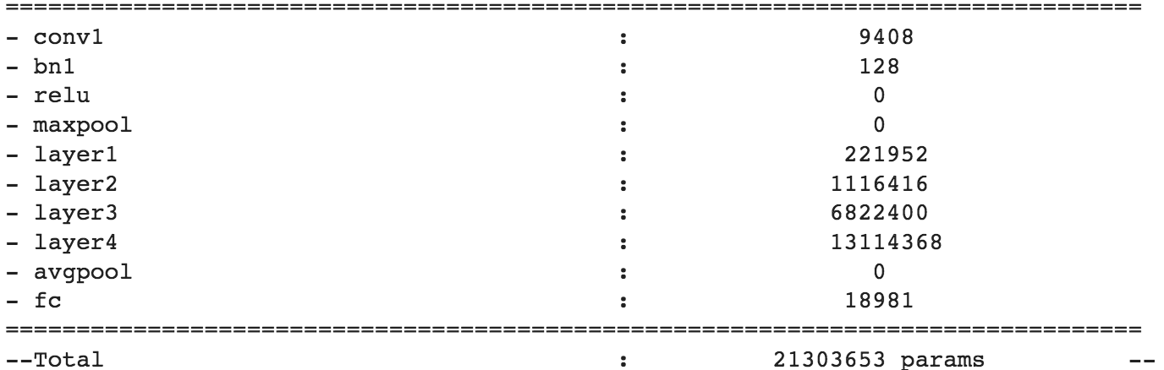
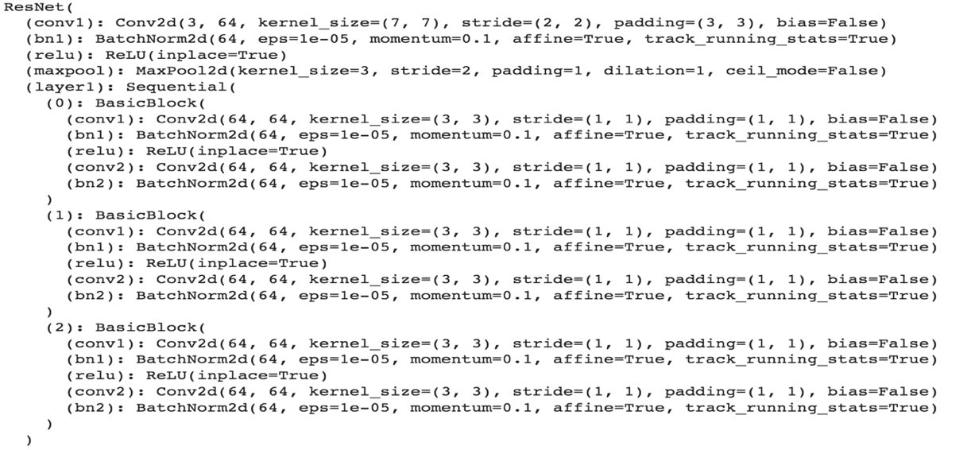
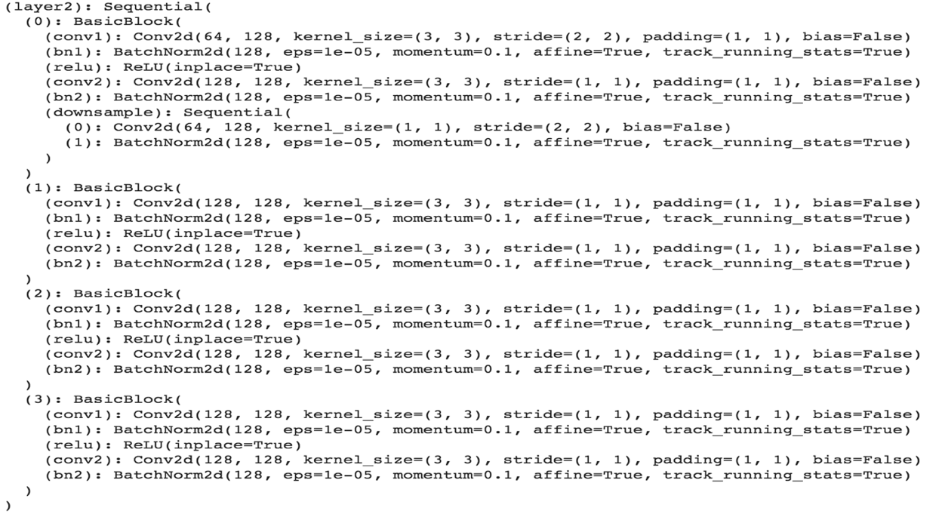
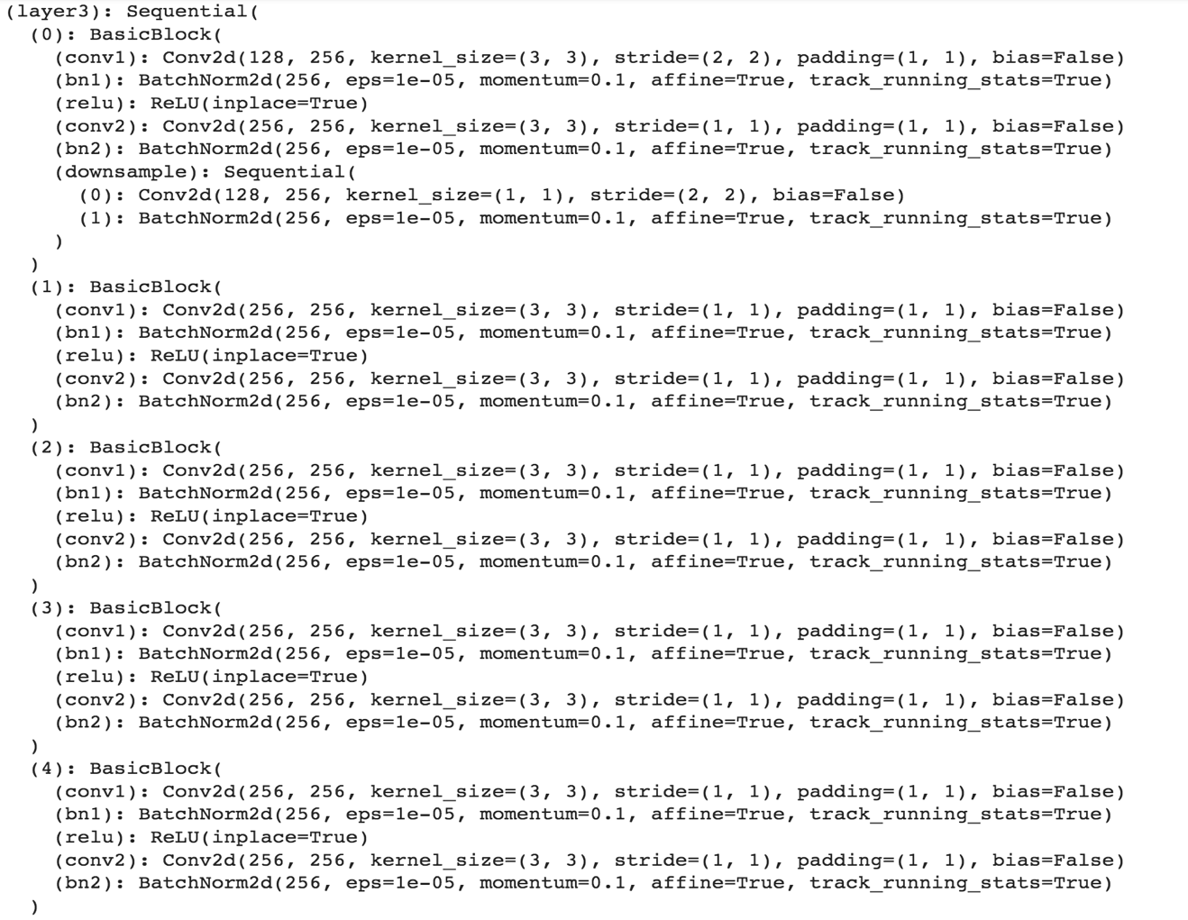
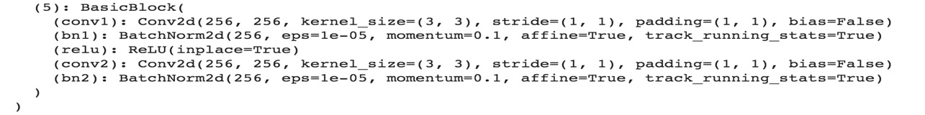
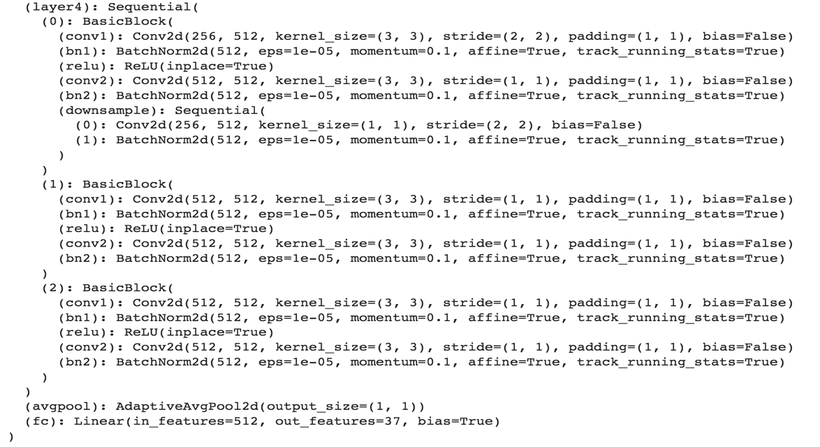

- Plot accuracy and loss:
Accuracy plot for training set and test set:
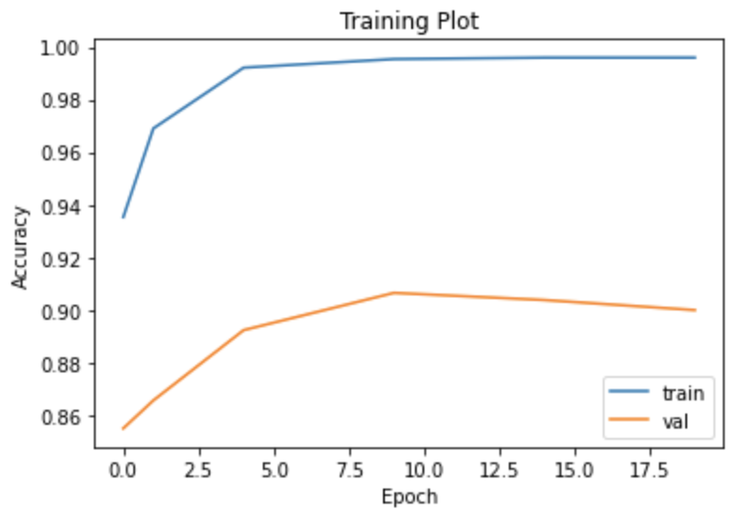
Loss plot for training set and test set:
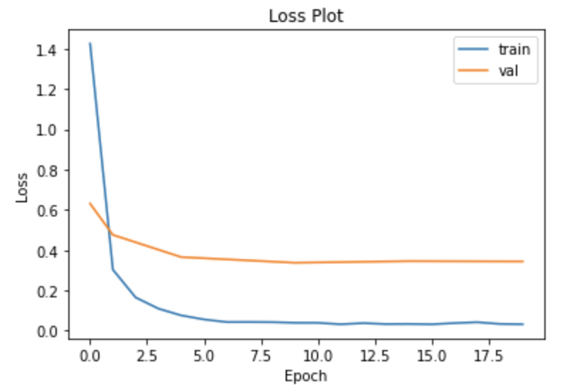

- Your best test accuracy:
My best test accuracy is: 0.902698282910875 => 90.270% (which is greater than 90%, and I got this within 20 epoches or fewer)

To achieve the best performance:
- I set the learning rate equal to 0.0001
- I set the step_size (which is a parameter of the learning rate scheduler) equal to 5
- I added two data augmentation fields (RandomHorizontalFlip, and RandomVerticalFlip)
- I did not change the batch_size at all

3. Answer “Applications of AI” Questions

- How is AI used in that application area? What is the problem that AI is trying to solve, and what are the key AI/ML technologies involved? What are the technical challenges? (100+ words) [10 pts]

I chose AI for agriculture as the application area to read two papers on. In this application area, AI is used for soil management, crop management, weed management, and disease management. The global population is increasing rapidly, and by 2050, the global population is expected to be over 9 billion people. So, the problem that AI is trying to slove in this application area is creating farming solutions that allow farmers to do more with less. Which improves the quality of crops and improves the speed of GTM (go-to-market strategy) when it comes to crops. Basically, farmers will need to produce more food for the increasing population. The key AI/ML technologies involved in this application area are using machine learning to identify plant stress, using AI and machine learning to predict protential pest attacks, and using sensor machine learning to save time and remove resistant weeds. The technical challenges in this application area include things such as large amount of data being required, the large amount of data costing a lot of money to obtain, the implementation method being difficult to find due to the large amount of data, and the data being obtainable only during certain times of the year due to farming seasons.

- What is the actual or potential positive impact? Who is impacted? (50+ words) [5 pts]

There are many positive impacts when it comes to AI being used for agriculture. Two groups of people who are positively impacted by AI being used for agriculture are farm owners, and the general public. These positive impacts include things such as farm owners being able to produce more food for the general public (and make more money), the general public having higher quality food, and the general public not having to worry about food shortages.

- What is the actual or potential negative impact? Who is impacted? (50+ words) [5 pts]

There are not many negative impacts when it comes to AI being used for agriculture, but there are a few. One group of people who are negatively impacted by AI being used for agriculture are the farmers that work for others. These negative impacts include things such as some farmers losing their jobs due to AI doing their jobs for them.
- What are your sources? (include full citations and links if available) [required; half credit if not provided]

Full Citations:

[1] Ngozi Clara Eli-Chukwu, “Applications of Artificial Intelligence in Agriculture: A Review”, Engineering, Technology & Applied Science Research, Vol. 9, No. 4, 2019, 4377-4383

[2] V. Dharmaraj, C. Vijayanand, “Artificial Intelligence (AI) in Agriculture”, International Journal of Current Microbiology and Applied Sciences, Vol. 7, No. 12, 2018, 2319-7706

Links (The first link is for the first citation, and the second link is for the second citation. The first link will take you directly to the paper. The second link will take you to a website where you can download the PDF of the paper.):

https://pdfs.semanticscholar.org/6e08/7108aa8048da8cfc82cdecb7071a55bab488.pdf

https://www.ijcmas.com/abstractview.php?ID=11203&vol=7-12-2018&SNo=241

4. Stretch Goals
- Compare word tokenizers
Report encodings for “I am learning about word tokenizers. They are not very complicated, and they are a good way to convert natural text into tokens.” and one additional sentence of your choice. 20 points for reporting trained encodings of at least two models. 10 points for one model. You must train the models on WikiText-2 (should be included in notebook code).

- The two 8k token word tokenizers that I trained on the WikiText-2 are BPE and WordPiece.
- One encoding report that I will discuss below is for the sentence: “I am learning about word tokenizers. They are not very complicated, and they are a good way to convert natural text into tokens.”
- Another encoding report that I will discuss below is for the sentence: “This is the second sentence that I am using to report the tokenizations. Hopefully the encodings will be different for both the BPE, and WordPiece tokenizers.”

One Sentence:

The first bracket is the encoding for the BPE tokenizer, and the second bracket is the encoding for the WordPiece tokenizer:

['I', 'am', 'learning', 'about', 'word', 'to', 'ken', 'izers', '.', 'They', 'are', 'not', 'very', 'complicated', ',', 'and', 'they', 'are', 'a', 'good', 'way', 'to', 'convert', 'natural', 'text', 'into', 'to', 'k', 'ens', '.']

['I', 'am', 'learning', 'about', 'word', 'to', '##ken', '##izers', '.', 'They', 'are', 'not', 'very', 'complicated', ',', 'and', 'they', 'are', 'a', 'good', 'way', 'to', 'convert', 'natural', 'text', 'into', 'to', '##ken', '##s', '.']

Another sentence:

The first bracket is the encoding for the BPE tokenizer, and the second bracket is the encoding for the WordPiece tokenizer:

['This', 'is', 'the', 'second', 'sentence', 'that', 'I', 'am', 'using', 'to', 'report', 'the', 'to', 'ken', 'izations', '.', 'Hope', 'fully', 'the', 'enc', 'od', 'ings', 'will', 'be', 'different', 'for', 'both', 'the', 'B', 'PE', ',', 'and', 'Word', 'Pie', 'ce', 'to', 'ken', 'izers', '.']

['This', 'is', 'the', 'second', 'sentence', 'that', 'I', 'am', 'using', 'to', 'report', 'the', 'to', '##ken', '##izations', '.', 'Hope', '##fully', 'the', 'enc', '##oding', '##s', 'will', 'be', 'different', 'for', 'both', 'the', 'BP', '##E', ',', 'and', 'Word', '##P', '##iece', 'to', '##ken', '##izers', '.']
- Your implementation of Network
  - Display the structure of the network you implemented
  - Plot accuracy and loss
  - Best test accuracy:

Acknowledgments / Attribution

List any outside sources for code or improvement ideas or “None”.

Sources:

- Course Lectures/Slides
- w3schools
- All of the PyTorch links that were provided in the tips and tricks google docs.
- https://pdfs.semanticscholar.org/6e08/7108aa8048da8cfc82cdecb7071a55bab488.pdf
- https://www.ijcmas.com/abstractview.php?ID=11203&vol=7-12-2018&SNo=241
- https://github.com/openai/CLIP
- https://www.ibm.com/topics/knn
- https://learn.g2.com/k-nearest-neighbor
- https://machinelearningmastery.com/logistic-regression-for-machine-learning/
- https://openai.com/research/clip
- https://arxiv.org/pdf/2103.00020.pdf

Improvement Ideas:

- I can’t think of any improvement ideas currently because this homework was very clear with the explanations.

